**EXPERIMENT 2:**

EXP. No. 2.a Write a shell script to compare two string.

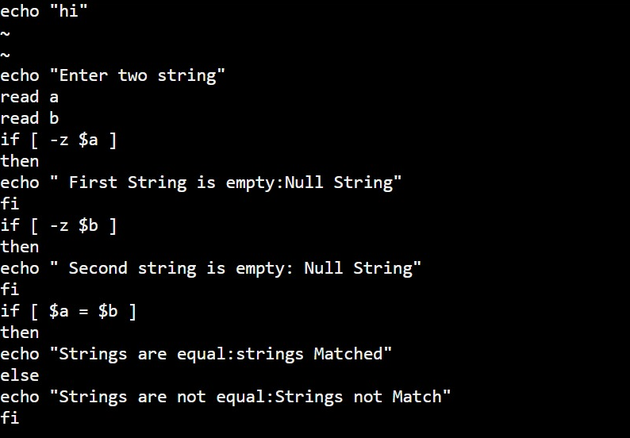

OUTPUT:

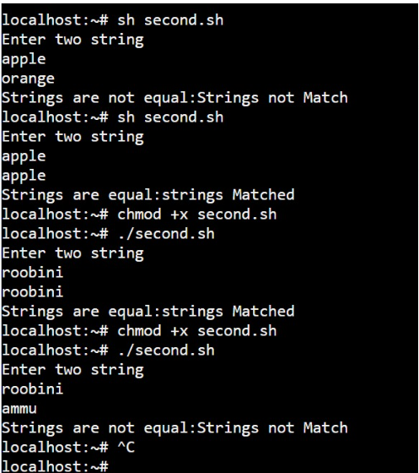

**EXP. No. 2.b Write a shell script to extract the first and last character from a string.**

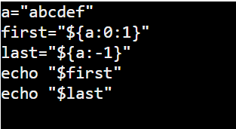

Output:

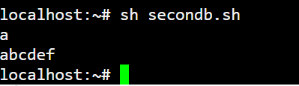

**EXP. No. 2.c Write a shell script to check whether the number is palindrome or not.**

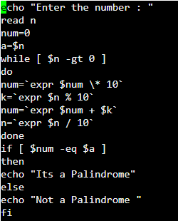

**Output:**

